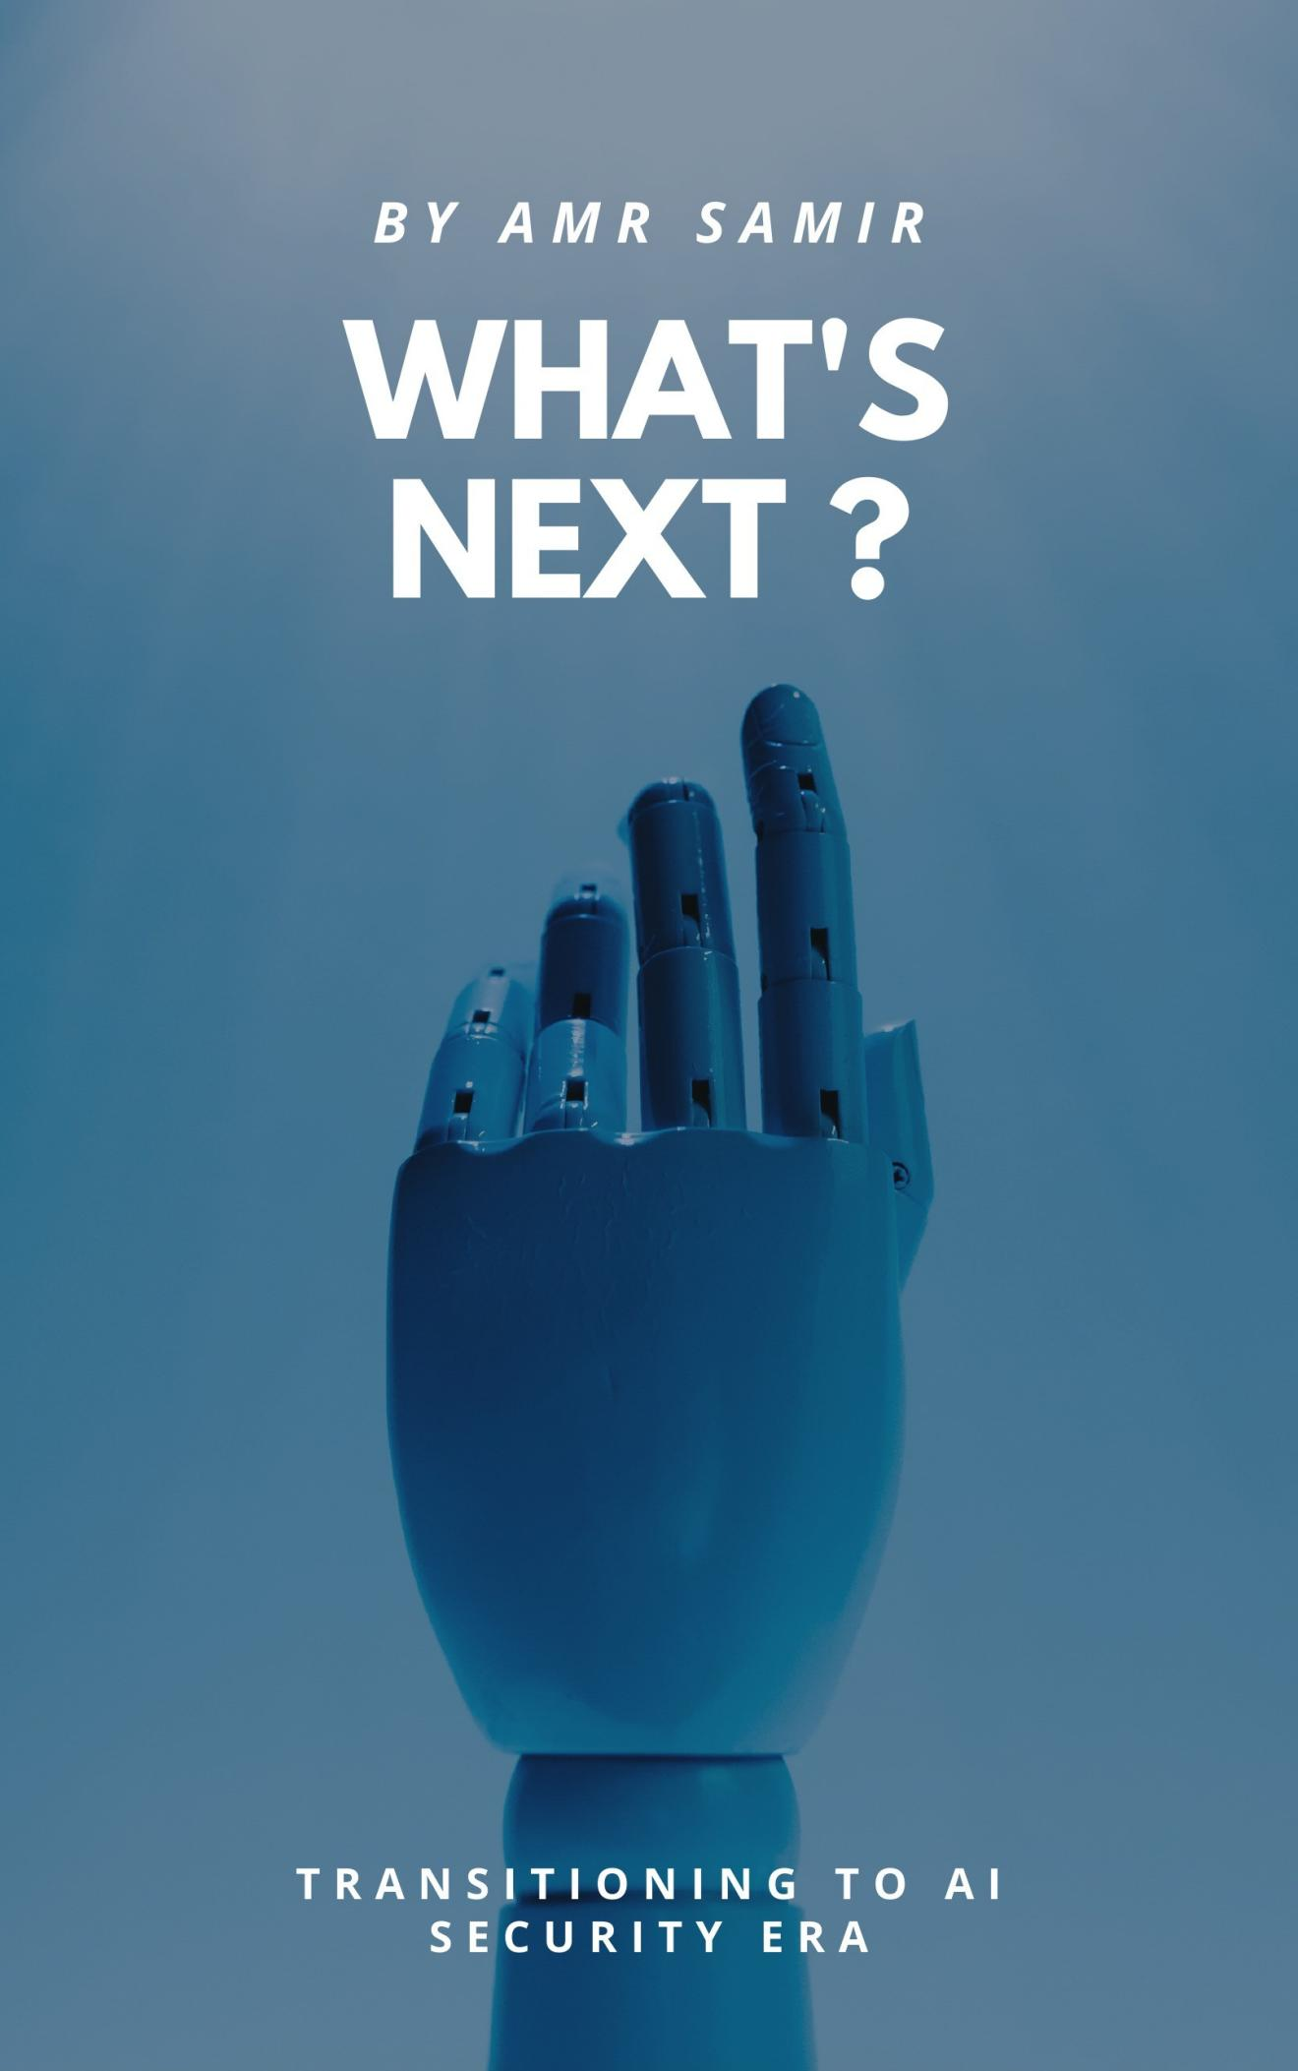


I N D E P E N D E N T R E S E A R C H • 2 0 2 6

WHAT’S
NEXT?
T R A N S I T I O N I N G T O A I S E C U R I T Y

How Artiﬁcial Intelligence is changing cybersecurity, reshaping existing roles, and creating new opportunities.

B Y
AMR SAMIR AWADEEN
IT Student @ Mansoura University | GRC & Cybersecurity Security+ • COBIT 2019 • ISO 27001 Provisional Implementer

GitHub: github.com/amrsamir13
LinkedIn: linkedin.com/in/amr-samir-88462a33a

F O R E W O R D

A NOTE BEFORE WE BEGIN

Artiﬁcial Intelligence is changing almost everything around us, and cybersecurity is no exception.
New technologies are emerging, existing security practices are evolving, and professionals are beginning to face a different set of challenges.
But what does this actually mean for someone studying or working in cybersecurity?
Should we focus on securing AI systems? Learn how to use AI in tradi-tional security roles? Explore entirely new specializations?
I started exploring these questions because I wanted to understand where the industry is heading and, more importantly, how I can prepare for it.
This publication brings together my research into ﬁve areas that I believe deserve attention. It explores what they involve, why they matter, the skills they require, and how someone at the beginning of their cybersecu-rity journey can start learning about them.
This isn't an attempt to predict the future or claim that traditional cyber-security roles are disappearing.
It's an attempt to understand what's changing, explore what's emerging, and ﬁgure out what's next.

LET' S FIND OUT.

I N S I D E

CONTENTS

I N T R O D U C T I O N
A Note Before We Begin 3
- The Question: What’s Next? 5
- Understanding the AI Security Landscape 1 3
P A R T 1 — T H E F I V E D I R E C T I O N S
- AI Governance, Risk & Compliance 25
- AI Red Teaming 38
- AI-Powered Security Operations 49
- AI-Driven IAM & Identity Security 58
- AI Agent Security 68
P A R T 2 — P R E P A R I N G F O R W H A T ’ S N E X T
- Comparing the Five Directions 79
- Building Your Path into AI Security 85
C O N C L U S I O N
1 0. What’s Next? The Future of Cybersecurity 93
R E S O U R C E S
References & Further Reading 98



01

C H A P T E R 1

THE QUESTION: WHAT'S NEXT?

1 .1 Cybersecurity Is Changing. Again.

Cybersecurity has never been a static industry.

Over the years, the way we protect systems has changed alongside the technology we use.
The growth of the internet introduced new security challenges. Cloud computing changed how organizations manage infrastructure. Mobile devices expanded the attack surface, and digital transformation made cy-bersecurity an essential part of almost every business.
Now, Artiﬁcial Intelligence is introducing another major shift.

AI is no longer limited to experimental projects or research laboratories. It is becoming part of everyday business operations, software develop-ment, customer services, data analysis, and security tools.
Naturally, cybersecurity is being affected too.

Organizations are exploring how AI can help detect threats, investigate suspicious activity, automate repetitive tasks, and support security decisions.
At the same time, they are adopting AI systems that introduce new vul-nerabilities and risks that need to be understood and managed.
This creates an interesting situation: AI is becoming both something cy-bersecurity professionals need to protect and something they can use to improve security.
And that's where our question begins.

1 .2 Two Sides of the Same Transformation

To understand where AI Security is heading, we ﬁrst need to separate two closely related ideas.

SECURI NG AI
As organizations introduce AI into their environments, those systems be-come part of the attack surface.
AI models, applications, data sources, APIs, and connected tools can all introduce security concerns.
For example:

- What happens if someone manipulates an AI system through prompt injection?
- Can sensitive information be exposed through an AI application?
- What if an AI agent is given excessive permissions?
- How can organizations verify that an AI system behaves securely?
- Who is responsible when an AI-powered system makes a harmful decision?
These questions create a growing need for professionals who understand both cybersecurity and the speciﬁc risks associated with AI.

USI NG AI TO I MPROVE CYBERSECURI TY
The other side is about using AI to make existing security operations more effective.
Think about a traditional Security Operations Center (SOC).

Analysts may spend hours reviewing alerts, investigating suspicious ac-tivity, correlating logs, and preparing incident reports.
AI can assist with some of these activities by summarizing information, identifying patterns, enriching alerts, and supporting investigations.

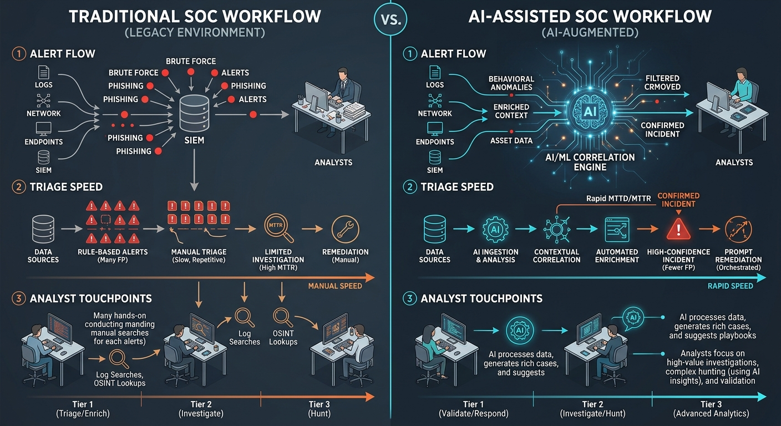

The same idea applies to other areas:

- GRC teams can use AI to support documentation, risk analysis, and de-cision-making.
- IAM teams can use intelligent analytics to identify unusual access patterns.
- Security analysts can use AI to assist with threat investigations.
- Security testers can use AI-assisted tools to explore potential weak-nesses and automate some reconnaissance phase activities.
AI does not automatically make these activities accurate or safe. Human validation, appropriate permissions, and proper security controls remain important.
The opportunity is to understand where AI can genuinely improve exist-ing work.

1 .3 Is AI Replacing Cybersecurity Professionals?

This is probably one of the biggest questions people have.

Will AI replace SOC analysts? Will automated tools replace penetration testers? Will organizations still need GRC professionals?

Cybersecurity is more complicated than completing individual tasks.

Security professionals don't simply operate tools. They understand busi-ness environments, assess risks, investigate unusual situations, make de-cisions, communicate with stakeholders, and take responsibility for their work.
AI can support many of these activities, but it also introduces new questions:
- Can the AI-generated result be trusted?
- Is the recommendation technically correct?
- Does the proposed action introduce additional risk?
- Does the organization have permission to perform that action?
- Who reviews and approves the ﬁnal decision?

These questions demonstrate why cybersecurity knowledge remains important.
The more AI becomes integrated into security environments, the more important it becomes to understand how these systems work, what they can do, and where their limitations exist.
Rather than viewing AI as a simple replacement for cybersecurity profes-sionals, it is more useful to understand it as a technology changing the responsibilities and capabilities of the profession.

1 .4 Five Directions Worth Exploring

This transformation is not happening in just one area of cybersecurity.

Some professionals are focusing on protecting AI systems. Others are ex-ploring how AI can improve established security functions.
In this publication, we'll explore ﬁve directions that represent different parts of this changing landscape.

- AI Governance, Risk & Compliance: How do organizations adopt AI re-sponsibly while managing security, regulatory, operational, and ethical risks?
- AI Red Teaming: How can we test AI systems, discover their weak-nesses, and understand how attackers might exploit them?
- AI-Powered Security Operations: How can AI help security teams de-tect threats, investigate incidents, and respond more effectively?
- AI-Driven IAM & Identity Security: How do we manage identities, permissions, and access when AI applications and automated services become part of organizational environments?
- AI Agent Security: How do we secure AI agents that can interact with tools, access information, execute actions, and operate with varying degrees of autonomy?
There is much more to cybersecurity roles that will be affected in the AI Era that deserves an honorable mention, but choosing these ﬁve to re-search reﬂects a targeted personal perspective.
These ﬁve directions are not completely separate. They overlap in several areas, particularly identity, risk management, monitoring, and security testing.
Some are extensions of established cybersecurity disciplines, while oth-ers are still developing into more recognizable specializations.
Understanding these differences will help us explore each one realistically.

1 .5 What Will You Get From This Publication?

This publication is designed to be more than an introduction to AI Security.
For each of the ﬁve directions, we'll explore:

- The Fundamentals: What the specialization actually involves and how it works.
- Real-World Applications: Where organizations can use it and why it matters.
- Threats and Challenges: The risks and problems professionals need to understand.
- Required Skills: The technical and professional knowledge needed to get started.
- Recommended Certiﬁcations: Relevant credentials and training worth considering.
- Useful Tools and Resources: Platforms, frameworks, documentation, and practical learning materials.
- A 12-Month Roadmap: A structured learning path showing what to study and practice month by month.
- A Portfolio Project: A practical project that helps turn theoretical knowledge into something demonstrable.
The roadmaps are intended as starting points, not guaranteed paths to employment. They will distinguish between foundational knowledge, hands-on experience, and optional certiﬁcations so readers can priori-tize their time and resources.
Whether you come from GRC, penetration testing, SOC operations, IAM, or a computer science background, the objective is to help you under-stand the opportunities and prepare for the direction that interests you most.

1 .6 The Journey Starts Here

AI Security is a broad and rapidly developing ﬁeld. There is no single cer-tiﬁcation, tool, or learning path that covers everything.

Trying to learn every new technology at once is neither realistic nor necessary.
What matters is building strong foundations, understanding how AI changes the security landscape, and developing practical skills that can be applied to real problems.
You don't need to become an AI researcher to understand AI Security. But you do need to understand enough about AI to recognize its capabili-ties, limitations, and risks.
The next chapter will establish those foundations before we explore the ﬁve career directions in detail.
The question isn't whether cybersecurity will change. It already is.
The question is: What's next, and how do we prepare for it?



02

C H A P T E R 2

UNDERSTANDING THE AI SECURITY LANDSCAPE

First, What Exactly Is Artificial Intelligence?

Before discussing AI Security, we need to understand what we are actu-ally trying to secure.
Artiﬁcial Intelligence (AI) is a broad ﬁeld of computer science focused on creating systems capable of performing tasks that typically require hu-man-like intelligence.
These tasks include recognizing patterns, understanding language, ana-lyzing information, making predictions, and generating content.
AI isn't a single technology. It includes several different approaches and technologies, such as:
- Machine Learning (ML): Systems learn patterns from data and use them to make predictions or decisions.
- Deep Learning: A branch of machine learning that uses multi-layered neural networks to process complex information.
- Natural Language Processing (NLP): Technologies that allow comput-ers to process and understand human language.
- Generative AI: Systems capable of generating new content, including text, images, audio, and code.
- Large Language Models (LLMs): AI models trained on large amounts of text and other data to understand and generate human language.

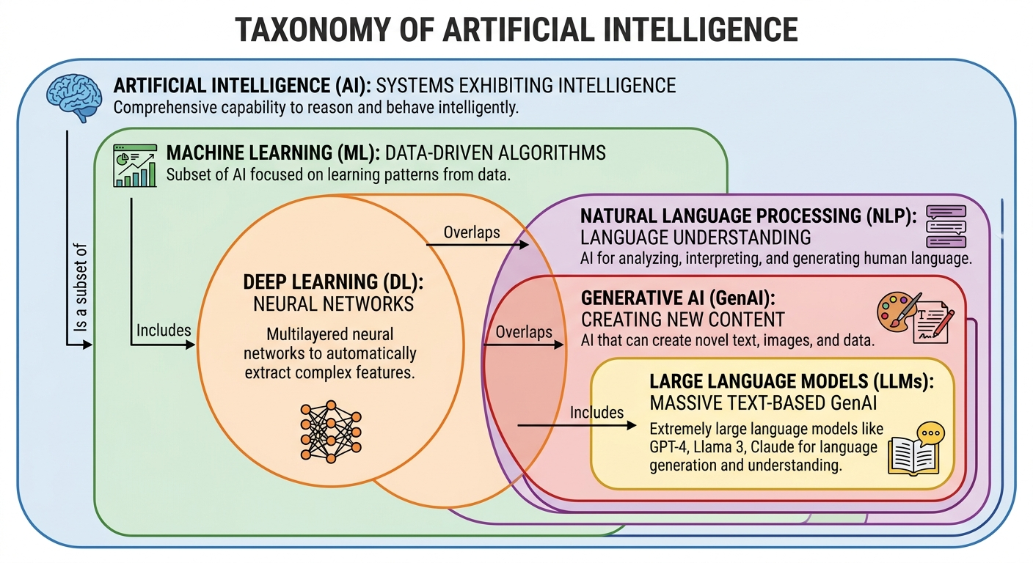
You have probably interacted with these technologies already, whether through recommendation systems, facial recognition, chatbots, or AI assistants.
However, one development has attracted particular attention: the rapid adoption of generative AI and LLM-based applications.
And this is where many of the new cybersecurity challenges begin.

Understanding Large Language Models (LLMs)

A Large Language Model is an AI model designed to process and generate language.
Tools such as ChatGPT and other AI assistants are examples of applica-tions built around these models.
Unlike traditional software, where developers explicitly deﬁne the logic behind every operation, an LLM generates responses based on patterns learned during training and the context provided during a conversation.
To understand how these systems work, let me break down a few key concepts.

Training
During training, a model processes large amounts of data and adjusts its internal parameters to learn patterns and relationships. The quality, rele-vance, and integrity of training data can inﬂuence how the model behaves.

Tokens
Models don't necessarily process text as complete words. They break in-put into smaller units called tokens. A token may represent a complete word, part of a word, punctuation, or another unit of text.

Context Window
The context window represents the amount of information a model can consider during a particular interaction. This may include instructions,

previous messages, retrieved documents, and other information supplied to the model.

Inference
Inference is the process of using a trained model to generate a prediction or response based on new input. When you send a question to an AI as-sistant and receive an answer, the model is performing inference.
Understanding these concepts matters because security issues can occur at different stages of an AI system's lifecycle, from training and data preparation to deployment and everyday usage.

How Modern AI Applications Work

An AI application is usually more than just a model.

A modern application may include several connected components:

    - A user interface.
    - An AI model.
    - An API connecting the application to the model.
    - A database or external information source.
    - Authentication and authorization mechanisms.
    - Logging and monitoring systems.
    - Additional tools or services that the AI can interact with.

Consider a company that develops an internal AI assistant for its employees.
An employee asks:
"Summarize the latest security policy and tell me whether I have access to the document."

The application may receive the request, authenticate the employee, re-trieve relevant information, send selected context to an AI model, and re-turn a generated response.

Every component introduces potential security considerations.

The model might receive information it should not access. The API might have weak authentication. The application might fail to enforce permis-sions. The generated response might expose conﬁdential information.
This is why securing an AI application requires more than checking whether the model produces safe answers.
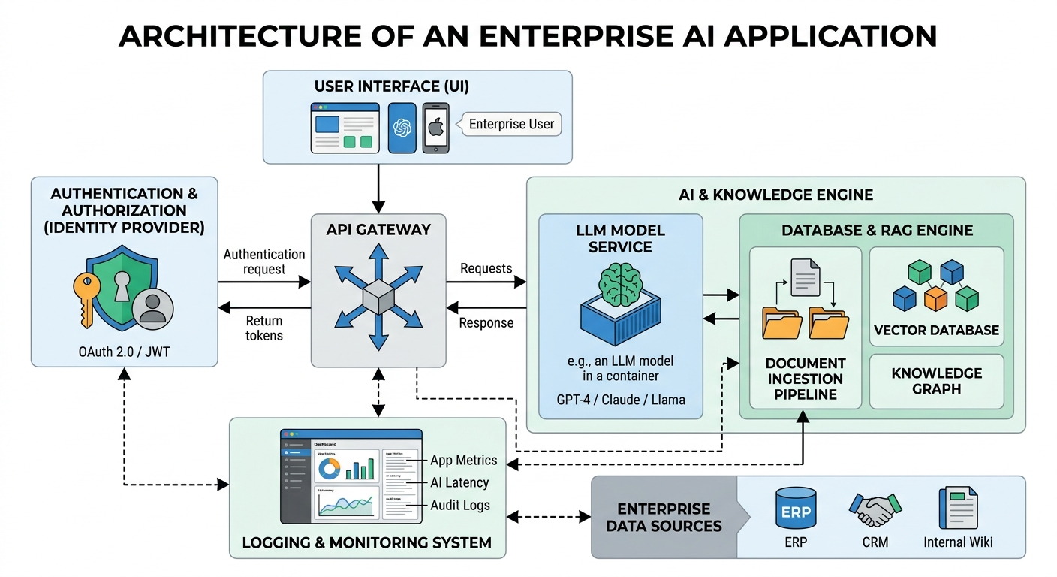

Three Technologies Worth Understanding

Before exploring the career directions, there are three concepts that will appear repeatedly throughout this publication.

API S — CONNECTI NG AI TO OTHER SYSTEMS
An Application Programming Interface (API) allows different software ap-plications to communicate.
For example, an application might send a request to an AI model through an API and receive the generated response.

APIs are important because they create connections between AI systems and other applications, databases, and services.
From a cybersecurity perspective, these connections introduce familiar concerns:
- Authentication and authorization.
- API keys and credential protection.
- Rate limiting and abuse prevention.
- Input validation.
- Data exposure.
- Access control.

An AI application with an insecure API can expose much more than just a chatbot.

RAG — GI VI NG AI ACCESS TO EXTERNAL KNOWLEDGE
Retrieval-Augmented Generation (RAG) is a technique that allows an AI application to retrieve relevant information from external sources before generating a response.
For example, a company may want its AI assistant to answer questions using internal policies and documentation rather than relying only on the model's existing knowledge.
A simpliﬁed RAG workﬂow looks like this:

- A user submits a question.
- The application searches for a connected knowledge source.
- Relevant documents or information are retrieved.
- The retrieved information is provided to the AI model as context.
- The model generates a response using that context.

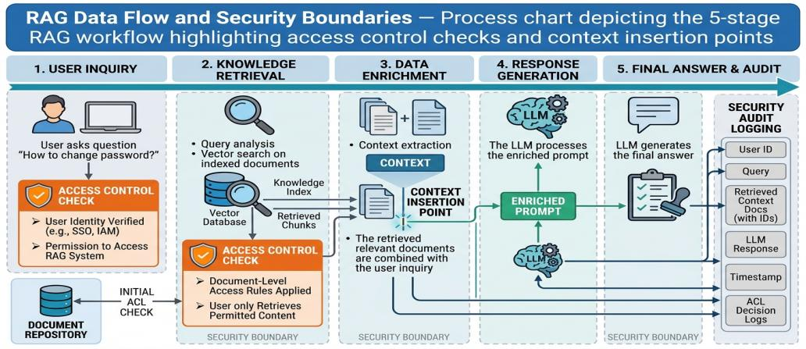

RAG is useful because it allows applications to work with information that may not have been included in the model's original training.
However, it also introduces security challenges.

What if an employee retrieves a document they are not authorized to ac-cess? What if an attacker inserts malicious instructions into a document that the AI later retrieves? What if information from one user's session becomes accessible to another?
These questions connect RAG directly to data security, identity manage-ment, access control, and AI Red Teaming.

AI AGENTS FROM GENERATI NG ANSWERS TO TAKI NG ACTI ONS
Traditional AI assistants mainly respond to user requests.

AI agents can go further by interacting with tools, accessing information, calling APIs, and performing actions to accomplish a task.
For example, imagine an AI agent designed to assist an IT department. It may be able to:
- Search internal documentation.
- Retrieve information from a ticketing system.
- Check user account details.
- Create support tickets.
- Request approval for certain actions.

This introduces an important difference.

An AI assistant that provides an incorrect answer may mislead a user.

An AI agent with excessive permissions might actually perform an unau-thorized action.
The more tools, permissions, and autonomy an agent receives, the more important identity, authorization, monitoring, and security boundaries become.
This is one of the reasons AI Agent Security is becoming an important area of exploration.

Securing AI vs. AI-Powered Security

Now that we understand some of the underlying technologies, let's re-turn to the two main directions introduced in Chapter 1.
They represent different security objectives.

Securing AI
The objective is to protect AI systems against threats and vulnerabilities.
Examples include:

- Preventing prompt injection.
- Protecting sensitive information.
- Securing model APIs.
- Preventing unauthorized access to AI applications.
- Protecting training and retrieval data.
- Restricting AI agent permissions.
- Monitoring AI system behavior.

AI-Powered Security
The objective is to use AI to improve existing cybersecurity capabilities.
Examples include:

- Analyzing security logs.
- Identifying unusual user behavior.
- Assisting with threat intelligence.
- Prioritizing security alerts.
- Supporting incident investigations.
- Automating selected security workﬂows.
- Assisting with risk analysis and documentation.

These directions can overlap.

For example, an organization might use an AI-powered SOC assistant to investigate suspicious activity while also needing to secure that assistant against data leakage, prompt injection, and unauthorized access.
In other words, AI can become both a security capability and a potential attack surface.

The New AI Attack Surface

Every new technology introduces new ways for systems to fail or be at-tacked. AI is no exception.
However, AI applications introduce some security challenges that differ from traditional software vulnerabilities. Let's examine a few important examples.
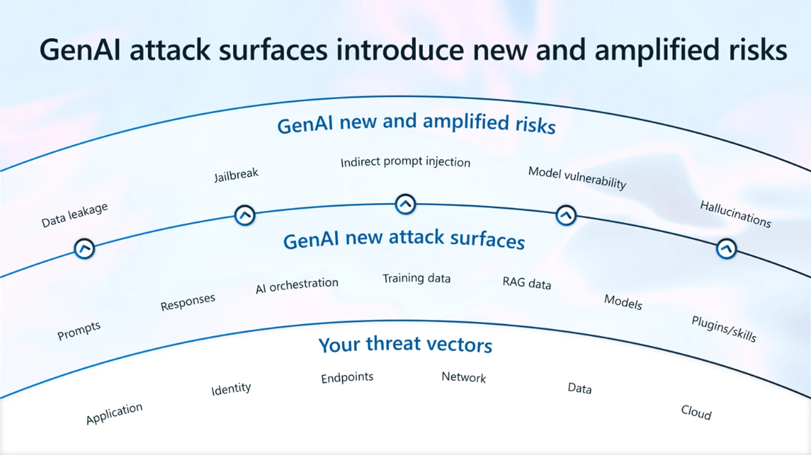

Figure showing the risk & attack surface and threat vector by Microsoft.
Prompt Injection: An attacker creates input that attempts to manipu-late an AI model into ignoring its intended instructions or performing unintended actions. This can happen through direct user input or through external content processed by the model. For example, a mali-cious instruction hidden inside a document might inﬂuence an AI as-sistant that reads and summarizes it.
Sensitive Information Disclosure: An AI application may expose conﬁ-dential information through its responses. This can happen when sen-sitive data is provided to a model without adequate controls or when the surrounding application fails to enforce access restrictions.
Data and Model Poisoning: Attackers may attempt to manipulate training data, ﬁne-tuning data, or other information used by an AI sys-tem. The objective may be to inﬂuence model behavior, introduce vul-nerabilities, or reduce the reliability of its outputs.
Excessive Agency: An AI application may be given more permissions or autonomy than it actually needs. If an attacker manipulates the system, excessive permissions can increase the potential impact.
Supply Chain Risks: AI applications often depend on external models, datasets, libraries, APIs, and third-party services. A compromised or poorly maintained component can introduce security risks into the wider application.
These examples demonstrate why traditional cybersecurity controls re-main important, but also why AI-speciﬁc security practices are necessary.
For a deeper understanding of these risks, the OWASP GenAI Security Project provides a dedicated risk classiﬁcation for LLM applications.

Where Traditional Cybersecurity Still Fits

One common misconception is that AI Security requires professionals to abandon everything they previously learned about cybersecurity.

That isn't the case.

Many of the most important security principles remain relevant:

- Identity and Access Management.
- Network Security.
- Application Security.
- Data Protection.
- Vulnerability Management.
- Security Monitoring.
- Risk Management.
- Incident Response.
- Governance and Compliance.

What changes is how these disciplines are applied.

For example:

- An IAM professional may need to manage identities and permissions for AI agents in addition to human users.
- A SOC analyst may use AI to investigate alerts while monitoring the se-curity of the AI tools themselves.
- A GRC professional may need to assess AI-related risks, governance re-quirements, and third-party AI services.
- A penetration tester may need to understand prompt injection, model behavior, and AI-speciﬁc attack techniques.
The foundations do not become irrelevant. They become part of a broader security landscape.

What Does This Mean for Your Career?

Understanding AI technology is becoming increasingly useful across dif-ferent cybersecurity disciplines.
However, not everyone needs to become a machine learning engineer or an AI researcher.
The knowledge required depends on the direction you choose.

A professional interested in AI Governance may need a stronger under-standing of risk management, regulations, controls, and AI lifecycles.
Someone interested in AI Red Teaming may need deeper technical knowledge of LLMs, APIs, application security, and adversarial testing.
An aspiring AI SOC professional may beneﬁt from SIEM experience, de-tection engineering, automation, and an understanding of AI-assisted investigations.
An IAM professional may need to understand non-human identities, ser-vice accounts, agent permissions, and authorization models.
Someone exploring AI Agent Security may need to understand agent ar-chitecture, tool integration, identity, sandboxing, and runtime security.
The ﬁve directions explored in this publication are different, but they share one important foundation:

Understanding cybersecurity ﬁrst, then learning how AI changes the way it is applied.
That is the starting point for everything that follows.



03

C H A P T E R 3

AI GOVERNANCE, RISK & COMPLIANCE

What Is AI Governance?

Organizations are adopting Artiﬁcial Intelligence to improve productivity, automate processes, analyze information, and support business decisions.
But adopting AI is not simply a matter of purchasing a tool and allowing employees to use it.
Organizations need to understand what AI systems they are using, what information those systems process, what decisions they inﬂuence, and what could happen if something goes wrong.
This is where AI Governance comes in.

AI Governance is the collection of policies, responsibilities, processes, and controls that guide how an organization develops, acquires, deploys, and uses AI.
It helps organizations answer questions such as:

- Are we using AI responsibly?
- Do we understand the risks associated with each AI system?
- Is sensitive information being protected?
- Who is accountable for AI-related decisions?
- Are our AI systems being monitored?
- Are we meeting applicable legal and regulatory requirements?

AI Governance is not just about preventing problems. It also helps orga-nizations adopt AI in a controlled and sustainable way.

Why Does AI Need Governance?

Traditional IT governance already addresses security, privacy, operational risk, compliance, and accountability.
However, AI introduces additional considerations.

For example, an organization may deploy an AI tool to help screen job ap-plications. If the system produces biased recommendations, the organi-zation may face ethical, legal, reputational, and operational consequences.
Another organization may introduce an AI assistant connected to internal documents. If access permissions are poorly conﬁgured, conﬁdential in-formation could be exposed.
A third organization may use AI to support ﬁnancial decisions. If the model produces inaccurate results, the organization needs to understand who reviews those results and who is responsible for the ﬁnal decision.
These examples demonstrate why organizations need more than techni-cal security controls.
They need governance structures that deﬁne how AI is approved, as-sessed, monitored, and controlled.

Understanding AI Risk Management

AI Risk Management focuses on identifying, evaluating, treating, and monitoring risks associated with AI systems.
Some important risk categories include:

Security Risk
AI systems may be exposed to prompt injection, data poisoning, unautho-rized access, model manipulation, or insecure integrations.

Privacy Risk
AI applications may process personal or conﬁdential information in ways that create privacy concerns or violate applicable requirements.

Operational Risk
An AI system may produce inaccurate results, become unavailable, be-have unexpectedly, or fail to perform its intended function.

Bias and Fairness Risk
AI systems may produce unfair outcomes because of biased data, unsuit-able design, or inappropriate deployment.

Third-Party Risk
Organizations may depend on external AI providers, models, APIs, datasets, and infrastructure. These dependencies introduce additional risks that need assessment.

Legal and Regulatory Risk
AI use may be subject to legal requirements, industry regulations, con-tractual obligations, and internal policies.

The important point is that AI risk is not limited to cybersecurity. It re-quires collaboration between security, legal, compliance, privacy, busi-ness, and technology teams.

Important AI Governance Frameworks and Standards

Professionals entering AI GRC should become familiar with several im-
portant resources.

NI ST AI RI SK MANAGEMENT FRAMEWORK (AI RMF)
The NIST AI RMF provides a voluntary framework for managing risks as-
sociated with AI systems.

It is organized around four core functions:
GOVERN : Establish responsibilities, policies, and organizational structures.
MAP : Understand the AI system, its context, and potential risks.
MEASURE : Evaluate and analyze identiﬁed risks.
MANAGE : Prioritize and respond to risks throughout the AI lifecycle.

This is an excellent starting point for understanding AI risk management.
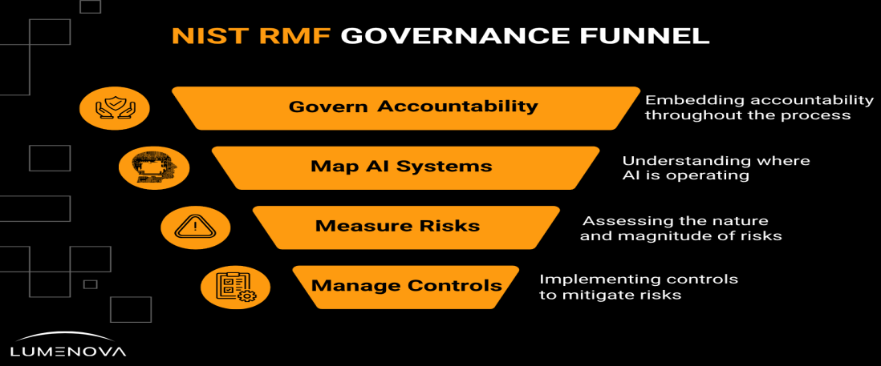

I SO/I EC 42001 : 2023
ISO/IEC 42001 speciﬁes requirements for establishing, implementing, maintaining, and continually improving an Artiﬁcial Intelligence Management System (AIMS).
It provides an organizational approach to managing AI-related responsi-bilities, risks, and opportunities.

For someone coming from an ISO 27001 or GRC background, this stan-dard is particularly relevant because it introduces a management-system approach to AI governance.

I SO/I EC 23894
This standard provides guidance on AI-related risk management. It helps organizations understand how risk management principles can be ap-plied to AI systems.

EU ARTI FI CI AL I NTELLI GENCE ACT
The EU AI Act establishes a regulatory framework for AI based on differ-ent categories of risk and associated obligations.
It is especially important for organizations developing, providing, or de-ploying AI systems within its scope.
Its implementation takes place in stages, so professionals must follow of-ﬁcial updates rather than relying on old summaries of its deadlines.

OWASP AI SECURI TY RESOURCES
OWASP provides technical resources that help translate AI security risks into practical security considerations.
For AI GRC professionals, these resources can support risk assessments, control selection, and discussions with technical teams.
These frameworks and standards serve different purposes. They should not be treated as interchangeable documents or as automatic proof of compliance.

What Does an AI GRC Professional Actually Do?

An AI GRC professional helps an organization understand and control the risks associated with its AI activities.
Responsibilities may include:

AI Inventory: Maintaining a record of AI systems used across the orga-nization, including their owners, purposes, providers, data types, and deployment environments.
AI Risk Assessments: Evaluating potential risks before an AI system is approved or introduced into business operations.
Policy Development: Creating or updating policies covering acceptable AI use, data protection, AI procurement, human oversight, and security requirements.
Third-Party Risk Management: Assessing AI providers and vendors to understand how they handle data, security, privacy, and operational responsibilities.
Control Mapping: Mapping applicable AI governance requirements to existing organizational controls and identifying gaps.
AI Audits and Assurance: Collecting evidence, reviewing processes, evaluating control effectiveness, and reporting ﬁndings.
Continuous Monitoring: Ensuring that AI systems remain within ap-proved boundaries as models, data, integrations, and business uses change.
The exact responsibilities depend on the organization. Some profession-als focus on governance and compliance, while others work more closely with technical AI security teams.

An Example: Introducing an AI Assistant in a Bank

Imagine a bank wants to introduce an AI assistant that helps employees
search internal policies and procedures.

Before deployment, the organization should ask several questions:

- What information can the assistant access?
- Can employees retrieve documents outside their authorization?

- Is customer information included in prompts?
- Who manages the AI service?
- How are prompts and outputs logged?
- What happens if the assistant provides incorrect information?
- Is there a human review process?
- Has the vendor been assessed?
- What happens when the system is updated?

The AI GRC professional helps coordinate these questions and ensures that appropriate controls and responsibilities are established.
The ﬁnal outcome might include an AI inventory entry, risk assessment, vendor assessment, approved-use policy, control mapping, and monitor-ing requirements.
This is what AI Governance looks like in practice: connecting technology, business objectives, risk, and accountability.

Skills and Knowledge to Develop

Someone entering AI GRC should build on traditional GRC knowledge rather than starting completely from zero.

Governance and Risk

    - Risk assessment and treatment.
    - Policies, standards, and procedures.
    - Internal controls.
    - Audit and assurance.
    - Third-party risk management.
    - Regulatory awareness.

AI Knowledge

    - AI and machine learning fundamentals.
    - LLMs and generative AI.
    - AI lifecycle and model deployment.
    - Data quality and model limitations.
    - AI security and privacy risks.

Frameworks

    - NIST AI RMF.
    - ISO/IEC 42001.
    - ISO/IEC 23894.
    - EU AI Act.
    - OWASP GenAI security resources.

Professional Skills

    - Documentation and reporting.
    - Communication with technical and business teams.
    - Risk presentation.
    - Evidence collection.
    - Critical thinking and decision-making.

You do not need to become a machine learning engineer to work in AI GRC. However, you should understand enough technical detail to ask meaningful questions and challenge weak answers.

Recommended Certifications and Learning

Certiﬁcations can help demonstrate structured knowledge, but they should support practical experience rather than replace it.

CERTI FI CATI ON OR QUALI FI CATI ON RELEVANCE

IAPP AIGP | Strong AI governance and regulatory  knowledge
ISO/IEC 42001 Lead Implementer | Implementing an AI management system
ISO/IEC 42001 Lead Auditor | Auditing an AI management system
ISO/IEC 27001 Lead Implementer / Auditor | Information security management foundations
CRISC | Enterprise IT risk management
CompTIA Security+ | General cybersecurity foundation

My recommendation: Start with NIST AI RMF and ISO/IEC 42001. Then consider AIGP or an ISO/IEC 42001 qualiﬁcation depending on your ca-reer direction, budget, and experience.
Do not collect all of these. Choose certiﬁcations that match the responsi-bilities you want to pursue, and verify current exam requirements and provider recognition before paying.

Your 1 2-Month AI GRC Roadmap

This roadmap is designed for someone who already has basic cybersecu-rity or GRC knowledge.

Months 1–2: Understand AI Fundamentals
Learn: AI, machine learning, and deep learning basics; Generative AI and LLM concepts; AI applications in business; AI lifecycle (development, de-ployment, monitoring, and retirement).
Goal: Explain how an AI system works and identify where governance and security risks can occur.

Months 3–4: Learn AI Risk Management
Study: NIST AI RMF; GOVERN, MAP, MEASURE, and MANAGE functions;
AI risk identiﬁcation and assessment; Privacy, fairness, transparency, and accountability; AI-related security threats.
Goal: Complete an AI risk assessment for a ﬁctional business use case.
Month 5: Study ISO/IEC 42001
Learn: AI Management System concepts; Organizational context; Leadership and responsibilities; Planning and risk treatment; Operational controls; Monitoring and continual improvement.
Goal: Understand how an organization can establish an AI management system.

Month 6: Explore AI Regulations and Standards
Study: EU AI Act; ISO/IEC 23894; NIST AI RMF; Relevant data protection requirements; Sector-speciﬁc requirements where applicable.
Goal: Create a comparison of the main frameworks and understand when each is relevant.

Month 7: Build Governance Documentation
Practice creating: AI acceptable-use policy; AI inventory; AI risk register;
AI vendor assessment questionnaire; AI system approval checklist.
Goal: Produce realistic governance documentation.

Month 8: Learn AI Security Controls
Study: OWASP GenAI resources; Data protection; Access control; Prompt injection; Logging and monitoring; Human oversight.
Goal: Map AI risks to practical controls.

Month 9: Learn AI Auditing and Assurance
Practice: Control testing; Evidence collection; Gap assessments; Audit re-porting; Corrective action tracking.
Goal: Complete a small AI governance assessment.

Month 10: Build Your Main Project
Design an AI Governance Management System for a ﬁctional organiza-tion, including an inventory, risk assessment, governance policies, control mapping, vendor assessment, approval process, and monitoring plan.

Month 11: Certiﬁcation Preparation
Choose one relevant certiﬁcation based on your objectives and budget (e.g., IAPP AIGP, ISO/IEC 42001 Lead Implementer, or ISO/IEC 42001 Lead Auditor).

Month 12: Publish and Prepare
Finalize your project, document your methodology, publish your work on GitHub, prepare an AI governance assessment presentation, practice ex-plaining your risk decisions, and begin applying for relevant GRC, AI gov-ernance, technology risk, and assurance opportunities.

PORTFOLI O PROJECT: AI GOVERNANCE FOR A FI CTI ONAL ORGANI ZATI ON
Build a small AI Governance program for a ﬁctional bank or enterprise.

Your project should include:

- AI system inventory.
- AI risk register.
- AI governance policy.
- Third-party AI vendor assessment.
- NIST AI RMF mapping.
- ISO/IEC 42001 management-system structure.
- Control assessment.
- Monitoring and review plan.

The objective is to demonstrate that you understand how governance works in a real organization, not simply that you have read a framework.

WHERE CAN THI S PATH LEAD?
Potential roles include:

- GRC Analyst with AI governance responsibilities.
- AI Governance Analyst.
- AI Risk Analyst.
- Technology Risk Analyst.
- AI Compliance Analyst.
- AI Assurance or Audit Associate.

Some of these are established job families with emerging AI responsibili-ties, while others are newer titles whose availability varies by market.
The main takeaway: AI GRC is about enabling organizations to use AI while understanding, managing, and taking responsibility for the risks that come with it.



04

C H A P T E R 4

AI RED TEAMING

What Is AI Red Teaming?

Traditional penetration testing focuses on identifying and exploiting weaknesses in systems, networks, applications, and infrastructure.
AI Red Teaming extends security testing into AI-powered systems.

Its purpose is to discover how an AI system can be manipulated, misused, or made to behave in unintended ways.
Instead of testing only traditional vulnerabilities such as SQL injection, broken authentication, or insecure conﬁgurations, AI Red Teamers also examine how models interpret instructions, handle untrusted informa-tion, interact with tools, and protect sensitive data.
For example, a company may deploy an AI assistant that can retrieve in-ternal documents.
A tester might investigate whether carefully crafted input can cause the assistant to reveal information it should not disclose.
This is not simply testing whether the model gives a strange answer. It is evaluating whether the complete AI application can be abused and what the business impact might be.

Why Do AI Systems Need Red Teaming?

AI systems behave differently from conventional applications.

Traditional software generally follows explicitly programmed logic. AI models generate outputs based on learned patterns and supplied context.
This introduces uncertainty.

A system may respond differently to similar inputs, misunderstand in-structions, or be inﬂuenced by information that was never intended to control its behavior.

When AI applications are connected to databases, APIs, internal docu-ments, or external tools, these weaknesses can have consequences be-yond an incorrect response.
An attacker might attempt to expose conﬁdential information, manipu-late an agent, trigger unauthorized actions, or abuse the application's integrations.
AI Red Teaming helps organizations discover these weaknesses before they become incidents.

Important AI Attack Techniques

Prompt Injection
An attacker attempts to manipulate an AI system through malicious in-structions included in user input or external content. For example, a ma-licious document may contain instructions designed to inﬂuence an AI assistant that reads and summarizes it.

Jailbreaking
Attempts to bypass a model's intended safety restrictions and make it generate responses or perform tasks it would normally refuse.

Sensitive Information Disclosure
Testing whether a model or its surrounding application can expose pri-vate data, conﬁdential documents, credentials, or information belonging to another user.

Data Poisoning
Manipulating training or other data used by an AI system to inﬂuence its behavior.

Model Denial of Service
Abusing an AI application in ways that consume excessive computational resources or increase operational costs.

Insecure Output Handling
Testing what happens when an application trusts model-generated out-put without properly validating or handling it.

Excessive Agency
Evaluating whether an AI application has unnecessary permissions or can perform actions beyond its intended responsibilities.
These are examples of security testing areas, not a complete list of every AI attack technique.

Understanding the AI Attack Surface

An AI application has multiple components that need testing.
The Model: How does it respond to adversarial inputs? Can its behavior be manipulated?
The Data: Can sensitive information be exposed, poisoned, or retrieved by unauthorized users?
The Application: Does the application enforce access controls and vali-date model outputs?
The API: Can attackers abuse exposed endpoints, credentials, or integra-tions?
The Tools: Can an AI agent misuse connected tools or invoke actions without proper authorization?
The Infrastructure: Are models, dependencies, storage, and deployment environments properly protected?
This is why effective AI Red Teaming requires both AI knowledge and tra-ditional application security skills.

Frameworks and Tools

Several resources can help security professionals structure their testing.

OWASP GenAI Security Project
Provides security resources and risk classiﬁcations for generative AI and LLM applications.

MITRE ATLAS
A knowledge base of adversary tactics and techniques associated with AI systems. It helps security teams understand how attackers may target machine learning and AI-enabled systems.

OWASP AI Security Veriﬁcation Standard (AISVS)
Provides testable security requirements for AI-enabled systems across their lifecycle.

Microsoft PyRIT
The Python Risk Identiﬁcation Tool for generative AI is an open-source framework designed to support AI red teaming and risk identiﬁcation.

Garak
An open-source vulnerability scanner for LLMs that can help test models against different categories of weaknesses.
These tools are not replacements for understanding the system being tested. A scanner can identify potential issues, but the tester must vali-date ﬁndings and explain their impact.

What Does an AI Red Teamer Actually Do?

Responsibilities may include:

    - Understanding the architecture of an AI application.
    - Identifying trust boundaries and attack surfaces.
    - Reviewing model integrations and APIs.
    - Designing adversarial test cases.
    - Testing prompt injection and data leakage.
    - Evaluating agent permissions and tool usage.
    - Assessing the effectiveness of security controls.
    - Documenting reproducible ﬁndings.
    - Recommending mitigations.
    - Retesting after remediation.

A good AI Red Team report should explain what happened, how it hap-pened, why it matters, what the impact could be, and how the issue can be ﬁxed.

Skills to Develop

Cybersecurity Foundations

    - Networking and HTTP.
    - Linux fundamentals.
    - Web application security.
    - Authentication and authorization.
    - API security.
    - Vulnerability assessment.

AI Fundamentals

    - LLM architecture.
    - Tokens and context windows.
    - System prompts and model instructions.
    - RAG.
    - Tool calling and agent workﬂows.

Testing Skills

    - Threat modeling.
    - Adversarial testing.
    - Test-case development.
    - Python scripting.
    - API testing.
    - Security reporting.

Useful Tools

    - Python, Burp Suite, Postman, OWASP resources, MITRE ATLAS, Microsoft PyRIT, Garak.

Recommended Certifications and Learning

AI Red Teaming is still developing as a professional specialization. There is no single universally accepted certiﬁcation that qualiﬁes someone as an AI Red Teamer.
Instead, build a combination of established security knowledge and prac-tical AI testing experience.
QUALI FI CATI ON RELEVANCE

CompTIA Security+ | General security foundation
eJPT | Entry-level practical penetration testing

QUALI FI CATI ON RELEVANCE

PNPT | Practical penetration testing and reporting
OSCP | Advanced practical offensive security
Relevant AI Security Training | AI-speciﬁc testing and attack techniques

Recommendation: Do not rush into expensive advanced penetration-testing certiﬁcations just to enter AI Red Teaming. First build web, API, Python, and LLM security skills.
Your ability to conduct a repeatable AI security assessment is more im-portant than having a long list of certiﬁcates.

Your 1 2-Month AI Red Teaming Roadmap

Month 1: Strengthen Technical Foundations
Learn Python basics, HTTP, REST APIs, Linux, networking, JSON, and au-thentication.
Goal: Understand how an application communicates with an AI service.

Month 2: Understand LLMs
Study tokens, context windows, model inference, system/user instruc-tions, temperature, output behavior, and basic model limitations.
Goal: Understand how an LLM processes requests.

Month 3: Learn AI Application Architecture
Explore model APIs, RAG, embeddings, vector databases, tool calling, and AI application architecture.
Goal: Map the components of a simple AI application.

Month 4: Study OWASP GenAI Risks
Focus on prompt injection, sensitive information disclosure, improper output handling, excessive agency, and supply-chain weaknesses.
Goal: Create a list of test scenarios for a sample application.

Month 5: Learn AI Threat Modeling
Study trust boundaries, attack surfaces, data ﬂows, threat actors, and MITRE ATLAS.
Goal: Create an AI threat model.

Month 6: Start Practical Testing
Use controlled environments to test prompt injection, jailbreak resis-tance, data exposure, output handling, and access-control weaknesses. Goal: Produce a structured test report.

Month 7: Learn AI Security Testing Tools
Explore Microsoft PyRIT, Garak, Burp Suite, and custom Python testing scripts.
Goal: Automate a small set of repeatable tests.

Month 8: Study AI Application Veriﬁcation
Learn OWASP AISVS and practice mapping ﬁndings to security require-ments.
Goal: Build an AI security veriﬁcation checklist.

Month 9: Test RAG Applications
Build or use a controlled RAG application. Test unauthorized document retrieval, malicious retrieved content, data separation between users, and retrieval access controls.
Goal: Document ﬁndings and mitigations.

Month 10: Test an AI Agent
Assess a controlled agent that uses a small number of tools. Evaluate tool permissions, prompt injection, unauthorized actions, input validation, and logging.
Goal: Complete an agent security assessment.

Month 11: Develop a Professional Report
Prepare executive summary, scope, methodology, ﬁndings, severity as-sessment, reproduction steps, and remediation recommendations.
Goal: Produce a professional AI Red Team report.

Month 12: Publish and Prepare
Publish a sanitized version of your assessment, document your tools and methodology, prepare a portfolio, review relevant job descriptions, and apply for suitable application security, security testing, and AI security opportunities.

Portfolio Project: AI Security Assessment Lab

Build a small AI application and conduct a controlled security assessment.
Your project should include:

    - A simple LLM-powered application.
    - A documented architecture and data ﬂow.
    - A threat model.
    - A collection of adversarial test cases.
    - Testing for prompt injection and information disclosure.
    - Access-control testing.
    - A ﬁndings report.
    - Recommended security improvements.
    - Retesting results.

Keep testing within systems you own or have explicit permission to assess.
The objective is to demonstrate that you can identify weaknesses, explain their impact, and recommend practical ﬁxes.

WHERE CAN THI S PATH LEAD?
Potential roles include:

    - Application Security Engineer.

    - Security Researcher.
    - AI Security Engineer.
    - AI Red Team Specialist.
    - Product Security Engineer.
    - Penetration Tester with AI security responsibilities.

AI Red Teaming is a technical path. Strong application security founda-tions will remain valuable even as AI-speciﬁc testing methods evolve.
The main takeaway: AI Red Teaming is not just about making a model produce an unexpected answer. It is about understanding how an AI-en-abled system can be attacked and what the consequences could be.

05

C H A P T E R 5

AI-POWERED SECURITY
OPERATIONS

What Is an AI-Powered SOC?

A Security Operations Center (SOC) is responsible for monitoring an organization's environment, identifying suspicious activity, investigating potential incidents, and coordinating responses.
Traditional SOC teams work with large amounts of security telemetry from endpoints, networks, applications, cloud platforms, and identity systems.
The challenge is that security teams often need to process more informa-tion than they can efﬁciently investigate manually.
Artiﬁcial Intelligence can help by analyzing data, summarizing alerts, identifying patterns, assisting investigations, and automating selected workﬂows.
An AI-Powered SOC uses these capabilities to support security operations.
It does not necessarily mean replacing analysts with autonomous AI sys-tems. In many cases, AI is most useful as an assistant that helps analysts work faster and make better-informed decisions.

The Traditional SOC Workflow

A typical SOC workﬂow includes several stages:

    - Monitoring: Collecting security events from different sources.
    - Detection: Identifying suspicious behavior through rules, analytics, threat intelligence, and other detection mechanisms.
    - Alert Triage: Determining which alerts require investigation and prior-itizing them according to potential risk.

    - Investigation: Collecting evidence, analyzing activity, and understand-ing what happened.
    - Response: Taking appropriate actions to contain or mitigate the incident.
    - Reporting: Documenting the incident, ﬁndings, decisions, and lessons learned.
AI can support several of these stages, but the quality of its output de-pends on the data, system design, and controls around it.

Where AI Can Help

Alert Summarization: AI can turn large amounts of technical information into more understandable summaries.
Alert Enrichment: An AI assistant can help combine alert details with threat intelligence, asset information, and historical context.
Investigation Support: AI can help analysts explore related events, gen-erate queries, and organize evidence.
Threat Hunting Assistance: AI can help translate investigation questions into queries or suggest patterns worth investigating.
Incident Documentation: AI can assist with timelines, summaries, and report preparation.
Workﬂow Automation: AI can support approved actions such as creating tickets, requesting additional information, or initiating predeﬁned re-sponse workﬂows.
These capabilities can reduce repetitive work, but they do not automati-cally guarantee accurate detection or successful incident response.

The Risks of AI in Security Operations

Using AI in a SOC introduces its own risks.
Hallucinations: An AI system may generate inaccurate explanations, in-vent details, or recommend actions without sufﬁcient evidence.
False Positives: AI-generated alerts or recommendations may identify harmless activity as suspicious.
False Negatives: An AI system may fail to recognize a genuine threat.

Data Exposure: Security logs and investigation data may contain conﬁ-dential information. Sending them to external AI services without appro-priate controls can create privacy and security issues.
Over-Automation: Allowing AI to isolate systems, disable accounts, or block trafﬁc without proper safeguards can create operational damage.
Lack of Explainability: Analysts may struggle to understand why a sys-tem produced a particular recommendation.
The most important principle is that AI-generated ﬁndings should be val-idated against evidence, especially before high-impact actions are taken.

The Role of the Human Analyst

Imagine an AI assistant detects unusual login activity.

It summarizes the affected account, identiﬁes unusual locations, and rec-ommends investigating a possible compromised identity.
The analyst still needs to verify the sign-in logs, examine related events, understand the user's normal behavior, and determine whether the activ-ity represents a genuine threat.

If the account needs to be disabled, the analyst must consider the opera-tional impact and follow the organization's incident-response procedures.
AI can help organize the investigation. It should not automatically be-come the ﬁnal authority for every security decision.

Skills and Tools

Security Operations

    - SIEM concepts.
    - Log analysis.
    - Incident response.
    - Threat hunting.
    - Detection engineering.
    - MITRE ATT&CK.

Technical Skills

    - KQL or SPL.
    - Python.
    - Networking.
    - Windows and Linux logs.
    - API integrations.

    - Automation and scripting.

AI Knowledge

    - LLM fundamentals.
    - AI-assisted investigations.
    - Prompt design and evaluation.
    - Data privacy.
    - Output validation.
    - Human oversight.

Tools to Explore

    - Microsoft Sentinel, Microsoft Defender XDR, Splunk, Elastic Security, Python, MITRE ATT&CK, AI-assisted security investigation tools.

Recommended Certifications and Learning
CERTI FI CATI ON RELEVANCE

CompTIA Security+ | General cybersecurity foundation
Microsoft SC-200 | Security operations, Sentinel, and Defender
Splunk Certiﬁcations | Splunk platform and security operations skills
Cloud Security Qualiﬁcations | Understanding cloud security environments

Recommendation: SC-200 is a strong option for someone pursuing Microsoft-based security operations. It covers threat investigation, hunt-ing, incident response, and KQL.
There is no need to collect several SIEM certiﬁcations. Choose a plat-form, learn it properly, and build practical investigation experience.

Your 1 2-Month AI SOC Roadmap

Month 1: Security Operations Fundamentals
Learn SOC responsibilities, event/incident concepts, networking basics, system logs, and MITRE ATT&CK.
Goal: Understand how a SOC operates.

Month 2: Learn SIEM Fundamentals
Choose one SIEM platform. Explore log ingestion, search/ﬁltering, de-tection rules, dashboards, and alert management.
Goal: Ingest and search security logs.

Month 3: Learn Detection and Investigation
Study authentication events, endpoint alerts, network events, suspicious processes, and detection engineering.
Goal: Investigate a small collection of simulated security events.

Month 4: Develop Query Skills
Learn KQL for Microsoft Sentinel or SPL for Splunk (ﬁltering, aggrega-tion, time searches, correlation).
Goal: Create useful investigation queries.

Month 5: Learn Python for Security Operations
Practice reading log ﬁles, parsing JSON, extracting indicators, automating analysis, and calling APIs.
Goal: Build a basic log-analysis script.

Month 6: Understand AI in Security Operations
Explore LLM-assisted investigations, alert summarization, threat intel enrichment, and AI query generation.
Goal: Build a simple AI-assisted alert analysis workﬂow.

Month 7: Learn Threat Intelligence
Study IOCs, threat intelligence sources, MITRE ATT&CK mapping, attack investigation, and threat context.
Goal: Enrich an investigation with external threat information.

Month 8: Incident Response and Automation
Learn incident classiﬁcation, containment, evidence preservation, play-books, and approval processes.
Goal: Design a controlled incident-response workﬂow.

Month 9: Build a SOC Lab
Create an environment with simulated logs, a SIEM platform, detection rules, and test alert scenarios.
Goal: Demonstrate an end-to-end SOC investigation.

Month 10: Integrate AI Assistance
Add an AI component to summarize alerts, suggest queries, explain events, and draft incident reports.
Goal: Build an AI-assisted SOC workﬂow with analyst validation.

Month 11: Evaluate the System
Test accuracy of summaries, recommendation quality, false positives/negatives, data handling, and human approval rules. Goal: Document what the AI improves and where it fails.

Month 12: Publish and Prepare
Complete documentation, publish your lab, prepare incident investiga-tion reports, consider SC-200, and apply for SOC roles.

Portfolio Project: AI-Assisted SOC Investigation

Build a small SOC investigation environment.

Your project should include:

    - A collection of simulated security events.
    - A SIEM platform or log-analysis environment.
    - Detection rules.
    - A set of investigation scenarios.
    - An AI assistant that summarizes selected alerts.

    - Investigation recommendations.
    - Analyst validation.
    - An incident report.
    - An evaluation of accuracy and limitations.

Do not allow the AI to execute destructive response actions in your initial project. Start with read-only assistance and controlled demonstrations.

WHERE CAN THI S PATH LEAD?
Potential roles include:

    - SOC Analyst.
    - Security Operations Analyst.
    - Detection Engineer.
    - Threat Hunter.
    - Incident Response Analyst.
    - Security Automation Engineer.

AI-assisted SOC capabilities are likely to become part of broader security operations responsibilities rather than always appearing as a separate job title.
The main takeaway: AI can help security analysts process information and investigate threats, but strong security fundamentals and human judgment remain essential.



06

C H A P T E R 6

AI-DRIVEN IAM & IDENTITY SECURITY

Why Identity Matters More Than Ever

Identity has become one of the most important parts of modern cybersecurity.
Organizations no longer manage access only for employees using ofﬁce computers.
They manage contractors, external partners, applications, service ac-counts, cloud workloads, APIs, automated processes, and increasingly AI-powered systems.
Every identity needs an appropriate level of access.

This becomes particularly important when AI applications can retrieve information, communicate with other systems, and perform actions on behalf of users or organizations.
An AI assistant with access to conﬁdential documents needs identity and authorization controls just like any other application.
An AI agent that can create tickets or modify systems needs even more careful permission management.
This is where AI-driven IAM and identity security become relevant.

Understanding IAM

Identity and Access Management (IAM) is the discipline of managing digi-tal identities and controlling access to organizational resources.
It answers three fundamental questions:

    - Who or what is requesting access?
    - How do we verify that identity?
    - What is it allowed to access or do?

IAM commonly includes:
    - Authentication: Verifying the identity of a user, application, or service.
    - Authorization: Determining what an authenticated identity is allowed to do.
    - Identity Lifecycle Management: Managing identities from creation to modiﬁcation and eventual deactivation.
    - Access Governance: Reviewing permissions and ensuring that access remains appropriate.
    - Privileged Access Management: Controlling access to sensitive sys-tems and administrative privileges.
These concepts remain essential as organizations introduce AI applica-tions and agents.

Human Identities vs. Non-Human Identities

Traditional IAM discussions often focus on human users.

However, modern environments also contain non-human identities.

Examples include:

- Service accounts.
- Application identities.
- Workload identities.
- Managed identities.
- API credentials.
- Automation identities.
- AI agents and services.

A non-human identity may need to access a database, retrieve a ﬁle, or communicate with another application.

The challenge is ensuring that it receives only the permissions required for its task.
An AI agent should not receive broad administrative access simply be-cause it needs to perform one limited operation.

AI Agents Need Identity and Authorization

Imagine an AI agent used by an IT department. It can:

    - Read support tickets.
    - Search internal documentation.
    - Check account information.
    - Create new tickets.
    - Request approval for account changes.

The organization needs to understand what identity the agent uses, what permissions it holds, and how its actions are recorded.
Important questions include:

    - Is the agent acting on behalf of a human user or under its own identity?
    - Can it distinguish one user's permissions from another's?
    - Are permissions limited to the required tools?
    - Can its access be revoked?
    - Are actions logged and attributable?
    - What happens when an agent is compromised?

These are not simply AI model questions. They are identity architecture and access-control questions.

Important IAM Concepts for AI Environments

Least Privilege: Give each identity only the permissions required for its task.
Role-Based Access Control (RBAC): Assign permissions through roles rather than managing every permission individually.
Attribute-Based Access Control (ABAC): Make authorization decisions based on attributes such as identity, resource, environment, and context.
OAuth 2.0: A framework commonly used for delegated authorization.
OpenID Connect (OIDC): An identity layer built on OAuth 2.0 that sup-ports authentication.
SAML: A standard used for exchanging authentication and authorization-related information, commonly in enterprise single sign-on environments.
Privileged Access Management: Controls elevated permissions and ad-ministrative access.
Workload Identity: Provides an identity for software workloads so they can authenticate to other services without relying on ordinary human accounts.
Understanding these technologies provides a strong foundation for man-aging AI-connected services.

The Risks of Poor AI Identity Management

    - Excessive Permissions: An AI agent may be granted broader access than its intended function requires.
    - Credential Exposure: API keys, tokens, or other credentials may be ex-posed through insecure storage, logs, or application behavior.
    - Identity Confusion: Systems may fail to distinguish between the hu-man user, the AI application, and the agent performing an action.
    - Weak Authorization: An application may authenticate a user correctly but fail to enforce the user's permissions when retrieving information or executing actions.
    - Unmanaged Non-Human Identities: Service accounts and machine identities may remain active without clear ownership or periodic review.
    - Poor Auditability: Organizations may struggle to identify which user or agent performed a particular action.
The goal is to make AI identities manageable, traceable, and restricted.

What Does an AI-Driven IAM Professional Do?

Responsibilities may include:

    - Designing identity architectures for AI applications.
    - Managing service and workload identities.
    - Reviewing AI agent permissions.
    - Implementing authentication and authorization.
    - Applying least-privilege principles.
    - Integrating AI applications with enterprise identity providers.
    - Managing secrets and credentials.
    - Reviewing access and monitoring identity activity.

    - Supporting privileged access management.
    - Establishing accountability for agent actions.

This is best understood as an evolution of established IAM and identity security work, rather than a completely separate universal job title.

Skills, Tools, and Certifications

IAM Foundations

    - Active Directory, Microsoft Entra ID, Identity lifecycle management, RBAC/ABAC, MFA, Conditional Access, SSO/Federation.

Protocols

    - OAuth 2.0, OpenID Connect, SAML, SCIM, API authentication.

Advanced Identity Topics

    - Workload identities, Managed identities, Service principals, Privileged access, Secrets management, AI agent authorization.

Tools

    - Microsoft Entra ID, PowerShell, Microsoft Graph, Postman, Keycloak, Cloud IAM platforms.

Recommended Certiﬁcations
CERTI FI CATI ON RELEVANCE

Microsoft SC-300 | Identity and access administration
CompTIA Security+ | General security foundation
Microsoft SC-100 | Advanced security architecture
Cloud IAM Qualiﬁcations | Cloud identity and workload access

SC-300 is a particularly relevant option for professionals interested in Microsoft identity environments. Its current objectives include workload identities, authentication, access management, and identity governance.

Your 1 2-Month AI IAM Roadmap

Month 1: IAM Foundations
Learn identity lifecycle, authentication, authorization, RBAC, least privi-lege, and access reviews.
Goal: Understand how enterprise IAM works.

Month 2: Directory Services and Identity Providers
Explore Active Directory, Microsoft Entra ID, users/groups, enterprise apps, and single sign-on.
Goal: Build and manage a basic identity environment.

Month 3: Identity Protocols
Study OAuth 2.0, OpenID Connect, SAML, SCIM, and API authentication. Goal: Understand how applications authenticate and exchange identity information.

Month 4: Microsoft Entra Administration
Practice user management, Conditional Access, MFA, enterprise apps, and app registrations.
Goal: Conﬁgure a basic enterprise identity environment.

Month 5: Identity Governance
Learn access reviews, entitlement management, lifecycle processes, PIM, and segregation of duties.
Goal: Design an identity governance process.

Month 6: Non-Human Identities
Study service principals, managed identities, service accounts, workload identities, and credential management.
Goal: Create an inventory of non-human identities and assess their permissions.

Month 7: AI Application Identity
Explore AI application authentication, API permissions, agent identity concepts, delegated vs. application permissions, and context boundaries. Goal: Design an identity model for a simple AI application.

Month 8: AI Agent Authorization
Study tool permissions, scoped access, short-lived credentials, autho-rization boundaries, and human approval steps.
Goal: Create a permission model for an AI agent.

Month 9: Identity Monitoring
Practice sign-in log analysis, app activity monitoring, credential rotation, and suspicious activity detection.
Goal: Build an identity monitoring dashboard or report.

Month 10: Build Your Main Project
Design an identity architecture for an organization using multiple AI agents (human identities, agent identities, workload identities, authenti-cation ﬂows, authorization rules, access reviews, audit logs).

Month 11: Certiﬁcation Preparation
Choose a relevant qualiﬁcation (recommended starting point: Microsoft SC-300).

Month 12: Publish and Prepare
Complete your architecture, document identity ﬂows, publish the project, prepare an IAM assessment, practice explaining access decisions, and apply for identity roles.

Portfolio Project: AI Identity Management Architecture

Design an enterprise identity architecture for an organization that uses AI assistants and agents.
Your project should include:

    - Human identity architecture.
    - Non-human identity inventory.
    - AI agent identity model.
    - Authentication design.
    - Authorization matrix.
    - Least-privilege permissions.
    - Credential management.
    - Access review process.
    - Audit and monitoring requirements.
    - Risk assessment.

Demonstrate how the organization can identify who initiated an action, which agent performed it, and what permissions were used.

WHERE CAN THI S PATH LEAD?
Potential roles include:

    - IAM Analyst.
    - Identity Governance Analyst.
    - Identity Security Engineer.
    - Access Management Specialist.
    - Cloud Identity Engineer.
    - Privileged Access Management Analyst.

The main takeaway: As AI systems gain access to organizational re-sources, identity and authorization become central to controlling what those systems can actually do.



07

C H A P T E R 7

AI AGENT SECURITY

From AI Assistants to AI Agents

Most people are familiar with AI assistants that answer questions, sum-marize documents, and generate content.
AI agents introduce another level of capability.

An agent can receive a goal, plan a sequence of steps, interact with tools, retrieve information, and perform actions within its assigned environment.
For example, an AI assistant might explain how to create a support ticket.

An AI agent could potentially search the ticketing system, collect the re-quired information, create the ticket, and report the result.
The difference is important.

An agent does not only generate information. It may interact with sys-tems and produce real-world effects.
That creates a new set of security responsibilities.

Understanding an Agent's Architecture

An AI agent may include several components:
    - Model: The model interprets instructions and helps decide what to do next.
    - Instructions and Goals: These deﬁne the agent's intended purpose and behavioral boundaries.
    - Tools: Tools allow the agent to interact with external systems, APIs, databases, and applications.
    - Memory and Context: These allow the agent to retain or retrieve in-formation relevant to its tasks.

    - Identity and Permissions: These determine which resources the agent can access and which actions it can perform.
    - Orchestration: The orchestration layer manages the agent's workﬂow and interactions between components.
    - Monitoring: Logging and monitoring help organizations understand what the agent did and why.

Every component introduces potential security weaknesses.

Why Are AI Agents Different From Traditional Applications?

Traditional applications generally follow predeﬁned workﬂows.

AI agents can make decisions about which tools to use and what steps to perform based on their interpretation of a task.
This ﬂexibility can be useful, but it also introduces uncertainty.

An agent may misunderstand a request, follow malicious instructions from external content, misuse a tool, or attempt an action outside its in-tended purpose.
If it has access to sensitive resources, the consequences can be signiﬁcant.

This is why AI agent security must consider not only the model, but also the tools, permissions, memory, data sources, and environment sur-rounding it.

Important AI Agent Security Risks

Agent Goal Hijacking: An attacker attempts to redirect an agent away from its intended objective.
Tool Misuse: An agent uses a connected tool in an unintended or unsafe way.
Identity and Privilege Abuse: An agent obtains or uses permissions be-yond what its task requires.
Agent Supply Chain Risks: Compromised tools, plugins, dependencies, or external components inﬂuence agent behavior.
Unexpected Code Execution: An agent executes unsafe commands or code based on untrusted input or poorly controlled instructions.
Memory and Context Manipulation: An attacker attempts to inﬂuence persistent information or context used by an agent.
Human-Agent Trust Exploitation: Users may trust an agent's recom-mendations or actions without appropriate veriﬁcation.
These risks are covered in more detail by OWASP's Top 10 for Agentic Applications.

Understanding MCP

The Model Context Protocol (MCP) is a protocol designed to connect AI applications with external tools and data sources through a structured interface.

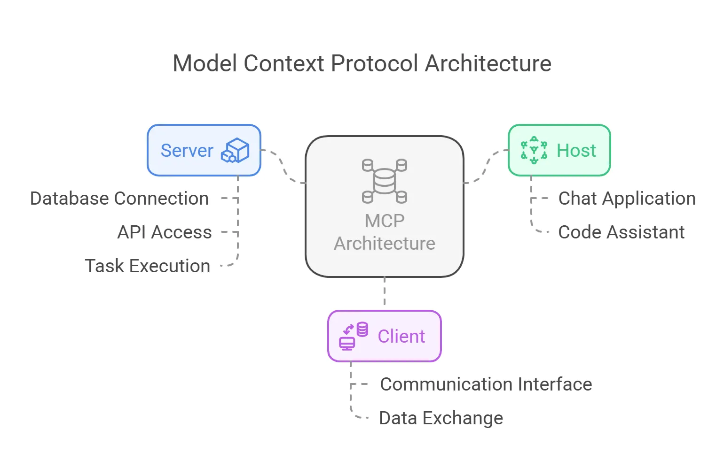
For example, an AI application may use an MCP server to interact with a database, retrieve documentation, or access a development environment.
This creates a standardized way for AI systems to interact with external capabilities.

However, every new connection introduces security considerations.

Organizations need to evaluate:

- Which MCP servers are trusted?
- What tools are exposed?
- How are users and agents authenticated?
- What permissions are granted?
- How are credentials protected?
- Are tool actions logged?
- Can malicious tool descriptions or content manipulate the agent?

OWASP has developed MCP-related security resources to help identify these risks.

The Principle of Least Agency

Traditional security often emphasizes the principle of least privilege.

AI agent security also needs to consider how much autonomy a system should receive.
An agent should only be able to perform the actions required for its task.

For example, an agent designed to summarize support tickets should not automatically have permission to delete accounts, modify production in-frastructure, or access unrelated customer records.
A secure design should consider:

- Limited tools.
- Restricted permissions.
- Clear task boundaries.
- Human approval for sensitive actions.
- Short-lived credentials where appropriate.
- Monitoring and audit trails.
- Safe execution environments.
- Reliable shutdown and revocation mechanisms.

The objective is not to eliminate useful autonomy. It is to control it.

What Does an AI Agent Security Professional Do?

This is an emerging area, not yet a universally standardized job title.

Responsibilities may include:

    - Reviewing agent architectures.
    - Identifying trust boundaries.
    - Assessing tool integrations.
    - Evaluating agent identities and permissions.
    - Testing prompt injection and goal hijacking.

    - Reviewing MCP servers and connected tools.
    - Securing memory and data retrieval.
    - Implementing sandboxing and execution restrictions.
    - Monitoring agent actions.
    - Designing approval and escalation mechanisms.
    - Conducting agent security assessments.

These responsibilities may currently appear under AI security, product security, application security, platform security, or AI engineering roles.

Skills and Tools to Develop

AI Foundations

    - LLM architecture, Prompting and context, Tool calling, RAG, Agent or-chestration, Memory systems.

Security Foundations

    - Application security, API security, IAM, Secrets management, Secure software development, Threat modeling.

Agent-Speciﬁc Security

    - Agent identity, Tool authorization, MCP security, Sandboxing, Runtime monitoring, Human approval workﬂows.

Tools and Resources

    - Python, OWASP Agentic Applications Top 10, OWASP MCP Top 10, Microsoft PyRIT, Containerization tools, Logging platforms.

Recommended Certifications and Learning

AI Agent Security is an emerging specialization. There is not yet a univer-sally recognized certiﬁcation that independently qualiﬁes someone for this work.
A stronger approach is to combine established qualiﬁcations with practi-cal agent security projects.
QUALIFICATION RELEVANCE

CompTIA Security+ | Security foundation
eJPT or equivalent | Practical security testing foundation
Microsoft SC-300 | Identity and access fundamentals
Cloud Security Qualiﬁcation | Securing cloud-hosted workloads
Specialized AI Security Training | Agent, LLM, and application security
For this path, OWASP's agentic security resources and practical testing experience are particularly important.
Do not buy a course simply because it uses the words "AI Agent Security." Evaluate its syllabus, labs, instructor credibility, and practical outcomes.

Your 1 2-Month AI Agent Security Roadmap

Month 1: Python and API Foundations
Learn Python, HTTP, REST APIs, JSON, authentication, and basic applica-tion architecture.
Goal: Build a small application that communicates with an API.

Month 2: Understand LLMs
Study tokens, context windows, system instructions, model inference, function calling, and limitations.
Goal: Build a basic LLM-powered application.

Month 3: Learn Agent Architecture
Explore agent loops, planning, tool calling, orchestration, multi-step workﬂows, and state.
Goal: Build a simple agent with one restricted tool.

Month 4: Learn RAG and Memory
Study embeddings, vector databases, retrieval, context management, persistent memory, and data separation.
Goal: Create a basic document-retrieval agent.

Month 5: Study Agent Security Risks
Learn prompt injection, goal hijacking, tool misuse, memory manipula-tion, data leakage, and excessive agency.
Goal: Create an agent threat model.

Month 6: Study OWASP Agentic Security
Explore OWASP Top 10 for Agentic Applications, OWASP MCP Top 10, trust boundaries, tool security, and supply-chain risks.
Goal: Map the main risks to potential security controls.

Month 7: Identity and Authorization
Learn service identities, agent identity concepts, OAuth/API authoriza-tion, least privilege, scoped permissions, and credential protection.
Goal: Design a permission model for an AI agent.

Month 8: Secure Tool Integration
Explore MCP architecture, tool validation, input validation, secure API in-tegration, tool restrictions, and logging.
Goal: Build an agent with limited, controlled tool access.

Month 9: Sandboxing and Execution Security
Study containers, isolated environments, execution restrictions, network restrictions, secrets management, and secure deployment.
Goal: Run an agent in a restricted environment.

Month 10: Build Your Main Project
Create a restricted AI agent that can perform a small number of approved tasks (incorporating identity, tool allowlisting, permission checks, human

approval steps, and logging).

Month 11: Conduct a Security Assessment
Test prompt injection, unauthorized tool access, excessive permissions, data leakage, memory manipulation, and unsafe execution.
Goal: Produce an agent security assessment report.

Month 12: Publish and Prepare
Publish architecture, document security controls, share safe testing re-sults, prepare a demonstration, review job descriptions, and apply for AI security/product security roles.

Portfolio Project: Building and Securing a Restricted AI Agent

Build an AI agent that can perform a small set of controlled tasks.

For example, an internal IT assistant that can:

    - Search approved documentation.
    - Read selected support tickets.
    - Create a draft ticket.
    - Request approval before performing a sensitive action.

Your project should include:

    - Agent architecture.
    - Threat model.
    - Identity and authorization design.
    - Tool allowlist.
    - Least-privilege permissions.
    - Restricted execution environment.
    - Human approval mechanism.
    - Monitoring and audit logging.

    - Security testing.
    - Final assessment report.

The most important part is demonstrating how you controlled the agent's ability to act.

WHERE CAN THI S PATH LEAD?
Potential opportunities may appear under titles such as:

    - AI Security Engineer.
    - Product Security Engineer.
    - Application Security Engineer.
    - AI Platform Security Engineer.
    - Agent Security Researcher.
    - Security Engineer focused on AI systems.

AI Agent Security is still developing, so readers should focus on transfer-able skills rather than searching only for a job title that may not yet be common.
The main takeaway: The more an AI system can do, the more carefully we must control what it is allowed to do.

08

C H A P T E R 8

COMPARING THE FIVE DIRECTIONS

Five Directions, Different Objectives

By now, we have explored ﬁve areas that represent different ways cyber-security is evolving alongside Artiﬁcial Intelligence.
Although they share common foundations, their objectives and day-to-day responsibilities can be very different.
Some focus on organizational governance and risk. Others involve tech-nical testing, security operations, identity architecture, or securing au-tonomous systems.
Understanding these differences can help readers decide where to focus their learning.

Comparing the Five Paths
DI RECTI ON MAI N OBJECTI VE MAI N FOCUS

AI GRC | Manage AI risks and  governance | Risk, controls, policies, compliance
AI Red  Teaming | Discover AI vulnerabilities | Adversarial testing and security assessment
AI SOC | Improve security  operations | Detection, investigation, response
AI-Driven IAM | Control identities and access | Authentication, authorization,  permissions
AI Agent  Security | Secure autonomous  agents | Agent architecture, tools, autonomy, trust

Each direction requires a different balance of technical knowledge, secu-rity experience, and organizational understanding.

Which Path Is More Technical?

AI Red Teaming and AI Agent Security generally require deeper hands-on technical skills. They involve understanding application architecture, APIs, model behavior, tool integrations, and security testing.
AI-Powered SOC requires strong operational knowledge, log analysis, de-tection engineering, and investigation skills.
AI-Driven IAM requires a combination of technical identity administra-tion, architecture, security controls, and governance.
AI GRC generally places greater emphasis on risk management, docu-mentation, governance frameworks, compliance, and communication with business stakeholders.
However, these distinctions are not strict. An AI GRC professional still needs technical awareness, and a technical security engineer still needs to understand risk and accountability.

Which Path Builds on Existing Cybersecurity Experience?

Different backgrounds can provide useful starting points.

If you come from GRC: AI Governance is a natural direction to explore. Existing experience with risk assessments, ISO standards, audits, and controls can provide a strong foundation.
If you come from Penetration Testing: AI Red Teaming is a logical area to investigate. Web security, API testing, vulnerability analysis, and report-ing skills are transferable.
If you come from SOC: AI-Powered Security Operations builds on SIEM, detection engineering, threat hunting, and incident response experience.
If you come from IAM: AI-Driven Identity Security builds on authentica-tion, authorization, identity governance, and non-human identity management.
If you come from Software or Cloud Engineering: AI Agent Security may be particularly interesting because it combines application architecture, APIs, infrastructure, identity, and AI-speciﬁc risks.
These are starting points, not restrictions. A professional can move be-tween directions by developing the required knowledge.

Established Roles vs. Emerging Specializations

It is important to distinguish between established career families and emerging specializations.
GRC, IAM, SOC, application security, and penetration testing are estab-lished areas of cybersecurity.
AI Governance, AI Red Teaming, and AI Agent Security are developing ar-eas in which responsibilities may appear under existing job titles or as dedicated specialist positions.
For example, an organization may hire a GRC Analyst and assign AI gov-ernance responsibilities without creating a separate AI GRC department.

Similarly, AI agent security work may currently be performed by product security, application security, or platform engineering teams.
This means readers should not search for only one exact job title. They should also look for roles where the responsibilities overlap with their chosen direction.

Skills Shared Across All Five Directions

Despite their differences, the ﬁve areas share several important competencies.
AI Literacy: Understanding how modern AI systems work, their capabili-ties, and their limitations.
Cybersecurity Fundamentals: Understanding access control, data pro-tection, application security, monitoring, and risk.
Risk Awareness: Recognizing that AI systems can introduce security, pri-vacy, operational, and organizational risks.
Critical Thinking: Questioning AI-generated outputs instead of automat-ically accepting them.
Communication: Explaining technical issues, security ﬁndings, and risks to different audiences.
Continuous Learning: Following developments in frameworks, threats, technologies, and security practices.
These shared skills are valuable regardless of which direction someone chooses.

Choosing Your Direction

Before selecting a specialization, consider the type of work you actually enjoy.

    - Do you prefer reviewing risks, developing policies, and communicating with business teams? AI GRC may be worth exploring.
    - Do you enjoy ﬁnding weaknesses, testing applications, and investigat-ing how systems can be compromised? AI Red Teaming may be a bet-ter ﬁt.
    - Do you enjoy monitoring environments, analyzing alerts, and respond-ing to incidents? Explore AI-Powered SOC.
    - Are you interested in identities, permissions, access architecture, and enterprise security? Consider AI-Driven IAM.
    - Do you enjoy building applications, connecting tools, and securing sys-tems that can take autonomous actions? AI Agent Security may be the direction to investigate.
You do not need to make a permanent decision immediately.

Try small projects from different areas, identify what interests you, and then invest more time in the direction that ﬁts your strengths and goals.



09

C H A P T E R 9

BUILDING YOUR PATH INTO AI SECURITY

You Don't Need to Learn Everything

One of the biggest mistakes when exploring a new technology ﬁeld is try-ing to learn everything at once.
AI Security is broad. It includes governance, machine learning, applica-tion security, identity, cloud infrastructure, threat detection, and more.
Trying to master all these areas simultaneously can lead to scattered learning and unnecessary spending.
A better approach is to build a foundation, choose a direction, and de-velop skills progressively.

Start With What You Already Know

Cybersecurity fundamentals remain valuable.

Depending on your background, you may already understand:

    - Networking.
    - Operating systems.
    - Authentication and authorization.
    - Security monitoring.
    - Vulnerability assessment.
    - Risk management.
    - Information security standards.
    - Application security.

These are not outdated skills. They are the foundation on which AI-spe-ciﬁc security knowledge can be built.

For example, someone with IAM experience does not need to abandon identity management to explore AI. They can build on that experience by studying workload identities and agent authorization.
Likewise, a GRC professional can build on existing risk and audit knowl-edge to explore AI governance.

Learn Enough AI to Understand the Technology

You do not need to become a machine learning researcher to begin ex-ploring AI Security.
However, you should understand the basic concepts.

Start with:

- Artiﬁcial Intelligence and Machine Learning.
- Deep Learning.
- Generative AI.
- Large Language Models.
- Tokens and context windows.
- APIs.
- RAG.
- AI agents.
- Model limitations and hallucinations.

Learn how these technologies are used in real applications. The goal is to understand the systems you may eventually need to secure or assess.

Choose a Primary Direction

After understanding the ﬁve areas, choose one primary direction.

You can still explore the others, but your main learning plan should focus on developing useful depth.
    - AI GRC: Focus on governance, risk, frameworks, and assurance.
    - AI Red Teaming: Focus on application security, AI testing, and adver-sarial techniques.
    - AI SOC: Focus on SIEM, detection, investigations, and automation.
    - AI IAM: Focus on identity architecture, authorization, and non-human identities.
    - AI Agent Security: Focus on agent architecture, tools, permissions, and runtime protection.
A focused learner with a meaningful project is generally in a stronger po-sition than someone who has completed many unrelated courses without demonstrating practical ability.

Certifications: Learn to Choose, Not Collect

Certiﬁcations can provide structure and help demonstrate knowledge.
However, they should be selected according to your career objective.

Before paying for an exam, ask:

- Is the certiﬁcation relevant to my target role?
- Does it cover knowledge that employers actually request?
- Is it recognized by the organizations I want to work for?
- Does it include practical learning or mainly theoretical content?
- Can I afford it without sacriﬁcing more important learning opportunities?
- Do I have enough foundational knowledge to beneﬁt from it?

A certiﬁcation is useful when it supports your development. It is not a substitute for being able to perform the work.

Build Projects That Demonstrate Your Skills

A portfolio gives you an opportunity to demonstrate what you can actu-ally do.
Instead of publishing only course completion certiﬁcates, create projects that solve realistic problems.
Examples include:
- AI GRC: Build an AI inventory, risk register, governance policy, and control assessment for a ﬁctional organization.
- AI Red Teaming: Assess an AI application, document vulnerabilities, and provide remediation recommendations.
- AI SOC: Create an AI-assisted investigation workﬂow that summarizes alerts and supports analyst decisions.
- AI IAM: Design an identity and authorization architecture for AI appli-cations and agents.
- AI Agent Security: Build a restricted AI agent and demonstrate how you protect its tools, permissions, and execution environment.
A good project should include a clear problem, methodology, implemen-tation, results, limitations, and documentation.

Make Your Portfolio Professional

A portfolio should be easy to understand.

For each project, include:

    - Project objective.
    - Architecture or workﬂow diagram.
    - Technologies and tools used.
    - Security requirements.

    - Implementation details.
    - Testing methodology.
    - Findings and results.
    - Limitations.
    - Lessons learned.

You can publish suitable work on GitHub or a personal portfolio website.

Do not publish conﬁdential information, real credentials, private com-pany data, or unauthorized security ﬁndings.

Recommended Learning Resources

The following resources provide useful starting points.

AI Fundamentals

    - Microsoft Learn — AI training.
    - Google Cloud — AI learning resources.
    - DeepLearning.AI — Introductory courses.

AI Governance

    - NIST AI RMF.
    - ISO/IEC 42001.
    - ISO/IEC 23894.
    - IAPP AIGP resources.

AI Security Testing

    - OWASP GenAI Security Project.
    - OWASP AISVS.
    - MITRE ATLAS.
    - Microsoft PyRIT.

    - Garak.

Security Operations

    - Microsoft Sentinel learning paths.
    - Splunk training.
    - MITRE ATT&CK.

Identity Security

    - Microsoft Entra documentation.
    - SC-300 learning resources.
    - OAuth and OpenID Connect documentation.

AI Agent Security

    - OWASP Top 10 for Agentic Applications.
    - OWASP MCP Top 10.
    - Model Context Protocol documentation.
    - CISA agentic AI security guidance.

Always check the current versions and availability of courses, exams, and documentation before beginning a learning plan.

A Practical Weekly Learning Routine

A roadmap only works if you can follow it consistently.

For someone balancing university, work, or other responsibilities, a man-ageable weekly schedule could look like this:
ACTI VI TY WEEKLY TI ME

Learning concepts | 2 hours
Ofﬁcial documentation and research | 1 hour

ACTI VI TY WEEKLY TI ME

Practical labs | 2 hours
Project development | 2 hours
Review and documentation | 1 hour
Total 8 hours

You can increase or reduce the time depending on your schedule.

Consistency matters more than trying to study for long hours and burn-ing out after a few weeks.

A Final Word About Career Preparation

The goal of learning AI Security should not be to chase every new tool, framework, or certiﬁcation.
Technology changes quickly. Tools that are popular today may be re-placed, updated, or integrated into other platforms.
Fundamental knowledge is more transferable.

Understanding identity, access control, risk, application security, data protection, monitoring, and secure system design will continue to be valuable.
AI-speciﬁc knowledge should build on these foundations.

Your objective is not to become an expert in everything. It is to become capable in one direction, understand how it connects to the wider secu-rity landscape, and remain adaptable as the industry evolves.



10

C H A P T E R 1 0

WHAT'S NEXT? THE FUTURE OF CYBERSECURITY

1 0.1 The Industry Is Evolving

Throughout this publication, we have explored how Artiﬁcial Intelligence is inﬂuencing cybersecurity from different perspectives.
We have seen how organizations need to secure AI systems, how security teams can use AI to improve their operations, and how existing disci-plines are developing new responsibilities.
One thing becomes clear: AI Security is not one single specialization.

It is a collection of interconnected technologies, responsibilities, and se-curity practices that affect different parts of the industry.
Some developments build on established disciplines such as GRC, IAM, SOC, and application security.
Others introduce new challenges involving autonomous agents, model behavior, and AI-speciﬁc attack surfaces.
The industry is not simply moving from traditional cybersecurity to AI Security. It is expanding, adapting, and combining existing expertise with new capabilities.

1 0.2 What Will Remain Important?

Despite all these changes, several cybersecurity principles remain essential.
Identity and Access Control: Systems need to verify identities and en-force appropriate permissions, whether access is requested by a human, an application, or an AI agent.
Risk Management: Organizations must understand what can go wrong, how serious the consequences could be, and which controls are needed.

Security Fundamentals: Networking, operating systems, application se-curity, data protection, and secure system design remain important foundations.
Monitoring and Accountability: Organizations need to understand what their systems are doing, identify suspicious behavior, and maintain ap-propriate records of important decisions and actions.
Human Judgment: AI can assist with analysis and recommendations, but organizations still need people who can evaluate evidence, understand business context, and take responsibility for decisions.
The tools may change, but the need for sound security principles does not disappear.

1 0.3 The Relationship Between Humans and AI

AI is increasingly capable of performing tasks that previously required manual effort.
It can help analyze information, generate code, summarize investigations, retrieve documentation, and support decision-making.
However, capability does not automatically equal reliability.

AI systems can make mistakes, misunderstand instructions, expose infor-mation, and behave in unexpected ways.
This creates an important responsibility for cybersecurity professionals: knowing when to use AI, when to question it, and when human interven-tion is necessary.
The future will likely involve closer collaboration between people and AI systems.
Professionals who understand how to use these technologies while rec-ognizing their limitations will be better prepared to work in that environment.

1 0.4 There Is More Than One Way Forward

Not everyone needs to become an AI Red Teamer or an AI Agent Security Engineer.
- A GRC professional can develop AI governance expertise.
- An IAM specialist can work on machine identities and agent permissions.
- A SOC analyst can become more effective through AI-assisted investi-gation and automation.
- A penetration tester can expand into AI application security testing.
- A software engineer can develop the skills needed to build and secure AI-powered applications.
There is no single correct career direction. The important thing is to un-derstand how your existing knowledge can connect to the changes hap-pening around you.

1 0.5 My Perspective

When I started exploring AI Security, I realized that the biggest challenge was not ﬁnding another AI tool or another certiﬁcation.
It was understanding how everything connects.

There are new frameworks to learn, new attack techniques to under-stand, and new technologies entering environments that cybersecurity professionals are already responsible for protecting.
At the same time, many of the fundamentals we have been learning for years remain relevant.
This is why I believe the best approach is not to abandon traditional cy-bersecurity knowledge, but to build on it.

For students and early-career professionals, this is an opportunity to ex-plore different directions early, experiment with new technologies, and develop skills before the ﬁeld becomes more familiar.
We do not need to predict exactly what the industry will look like ﬁve or ten years from now.
We need to stay curious, develop practical knowledge, and be willing to adapt.

Final Thoughts

Artiﬁcial Intelligence is changing cybersecurity, but the future is not de-termined by technology alone.
It will also depend on the people who build these systems, secure them, govern them, and decide how they should be used.
The ﬁve directions explored in this publication are only a starting point. New challenges and specializations will continue to emerge as AI capabil-ities develop.
If there is one message I hope readers take away, it is this:

Don't just follow the technology. Understand it. Question it. Learn how to secure it.
Because the question was never simply whether cybersecurity would change.
The question was whether we would be ready to change with it.

R E S O U R C E S
→

REFERENCES & FURTHER READING

The following resources provide the foundations for the topics discussed throughout this publication. They include international standards, cyber-security frameworks, government guidance, technical documentation, and practical security tools.
The resources are grouped by subject to make further learning easier.

AI Fundamentals

  - Microsoft Learn — Azure AI Fundamentals

  - Google Cloud — Artiﬁcial Intelligence and Machine Learning
  - DeepLearning.AI — Learning Resources

  - NIST — Artiﬁcial Intelligence

AI Governance and Risk Management

  - NIST — Artiﬁcial Intelligence Risk Management Framework

  - NIST — Generative Artiﬁcial Intelligence Proﬁle
  - ISO — ISO/IEC 42001:2023

  - ISO — ISO/IEC 23894:2023
  - European Commission — Regulatory Framework for Artiﬁcial Intelligence
  - IAPP — Artiﬁcial Intelligence Governance Professional

AI Security and Red Teaming

  - OWASP — Generative AI Security Project

  - OWASP — AI Security Veriﬁcation Standard
  - MITRE — ATLAS: Adversarial Threat Landscape for Artiﬁcial-Intelligence Systems

  - Microsoft — PyRIT
  - Garak — LLM Vulnerability Scanner

Security Operations

  - Microsoft Learn — Security Operations Analyst Associate (SC-200)

  - Microsoft — Microsoft Sentinel Documentation
  - MITRE — ATT&CK Framework

  - Splunk — Training and Education

Identity and Access Management

  - Microsoft Learn — Identity and Access Administrator Associate (SC-300)
  - Microsoft — Microsoft Entra Documentation
  - OpenID Foundation — OpenID Connect

  - OAuth — OAuth 2.0

AI Agent Security

  - OWASP — Top 10 for Agentic Applications 2026

  - OWASP — MCP Top 10
  - CISA and International Partners — Careful Adoption of Agentic Artiﬁcial Intelligence Services
  - Model Context Protocol — Ofﬁcial Documentation

Practical Learning and Development

  - GitHub — GitHub Skills

  - Microsoft Learn — Training
  - TryHackMe — Cybersecurity Training

  - Hack The Box — Academy
  - PortSwigger — Web Security Academy

A Note on Sources

Frameworks, regulations, certiﬁcations, and technical documentation may change after publication.
Readers should consult the original organizations for the latest versions, requirements, exam objectives, and implementation guidance.
The inclusion of a resource does not imply endorsement of this publica-tion by its issuing organization.

